**Academic Large-Scale Off-Target Movement Assessment of Dicamba - WI**

**2019 Trials**

**2019-01-B7-09**

This assessment will be designed to evaluate the physical and vapor drift from dicamba applications.

***1 Locations and contact information***

Field trials will be conducted at several locations in the US in collaboration with the people listed in Table 1.

***2 Field design and application***

The field design is detailed in Figure 1. All position labeling will be standardized based on geographic north of the field and numbers will be counted clockwise. The sprayed and surrounding areas will be cultivated with dicamba-tolerant (DT) soybeans, with similar maturity group, planted on 30” or 36” (0.76 or 0.91 m) spaced rows.

In cases where it is not possible to follow field layout and requirements due to any restriction, please contact Ryan Rector at Bayer Crop Science.

*2.1 Field requirements:*

Each spray plot will be as square, flat and uniform as possible with respect to slope, soil texture, and agronomic and pesticide use history. Ideally, the agronomic and pesticide history for the test site will be available for records. The test plot will have as minimal wind obstruction (buildings, hedgerow, etc.) as possible (at least 150 m from the edge of the spray block) and ideally be located at least approximately 1,000 feet away from other dicamba applications, if possible, occurring within ± 1 week of the application for this study. For all locations, please take images of the field condition and crop growth stage and height at the time of application.

XtendiMaxTM will be applied at 22 oz/acre (1.61 L ha-1), Roundup PowerMax® at 32 oz/acre (2.34 L ha-1), IntactTM at 0.5% v v-1 and MON 51817 at 1.0% v v-1. The treatment will be applied to DT soybeans at V3-V5 growth stage. The application volume will be 15 GPA (140 L ha-1) using TTI11004 nozzles at 50 PSI pressure. Applications should be made between 9:00 am and 2:00 pm at wind speeds ranging from 3 and 10 mph (1.3 and 4.5 m s-1). During the application, the sprayer will be turned around inside of sprayed area to avoid injuries on non-DT soybeans.

Two samples of the source water used for tank mixing should be taken for pH analysis. Additionally, at least two tank samples will be taken at the beginning and end of the application in appropriately labeled bottles. The person who mixes the solution and collects these samples will be classified as part of the contaminated crew and will not be allowed to collect any other samples. Tank samples should be stored in a dark and cool place, isolated from any other trial samples and sent to Bayer Laboratories in St. Louis, MO for pH analysis and herbicide concentration. Please ship the samples to:

Bayer Crop Science – Attn Mathew Juergens

AA5921-A

700 Chesterfield Parkway West

Chesterfield, MO 63017

*2.2 Weather station*

A weather station will be positioned close to the upwind edge (at the time of application) of the sprayed area. The station will have a data logger capable of recording measurements of each sensor every minute for the duration of the trial, including the application time. Try to set up the weather station so it is collecting data each second but reporting one-minute averages. Sensors will be mounted on a mast at approximately 0.33, 0.55, 0.90, and 1.50 m (13, 22, 35, and 59”) above canopy height. Each height will have a temperature/relative humidity sensor and a 2D Sonic Anemometer capable of detecting wind speed and direction. Care should be taken to ensure anemometers are accurately set to North. All sensors need to be properly programmed into the data logger and labeled accordingly. In addition, a rain gauge will be installed in the field to record precipitation during the trial. Once all collections are made, meteorological data should be exported, organized according to a model spreadsheet and sent to Ryan Rector at Bayer Crop Science.

***3 Physical and vapor drift evaluation***

*3.1 Deposition Collectors (physical drift)*

Filter papers (Whatman Filter Paper #1) with 150 mm diameter will be positioned on a horizontal stand and placed at the height of the non-DT soybeans in all Transects (Figure 1) at 7, 10, 13, 20, 26, 33, 49, 75, 98, 131 and 197 ft from the edge of the sprayed area. Two such lines of sample collectors will be used in each direction for the spray block.

Inside the spray block, 8-10 filter papers (Whatman Filter Paper #1) will be placed at canopy height using a similar horizontal stand as previously described. These will collect the direct application from the sprayer and act as the in-swath filters.

*3.2 Air samples (vapor and physical drift)*

A center mast containing 6 polyurethane foam (PUF) collectors and air pumps will be placed inside the spray block at the center point once the application is concluded. Those PUFs will be set up on a horizontal stand at 6, 13, 22, 35, and 59” (0.15, 0.33, 0.55, 0.90, and 1.50 m) above canopy. The sample tubes of the center mast should be arranged such that the open end of the tube points slightly down wind from the prevailing wind direction at the time of application. In order to prevent interference from the center mast post, the sample tubes should not be aligned directly downwind of the center mast. The height of the sample tubes should be verified and recorded immediately after the center mast is secured. See the illustration below.



The glass PUF holder should be recessed ~1” in the PVC piping that is mounted on the center mast. See the figure below.



The 1.50 m height PUF on the center mast will have two air samplers for duplication. Additionally, one air sampler will be positioned at 22” (0.55 m) above the canopy outside of each corner of the sprayed area [50 ft (15 m) from it] (See Figure 1). The perimeter air samplers located outside of the sprayed block and directly behind a covered tarp area will be positioned 100 ft from the spray block according to the figure below.

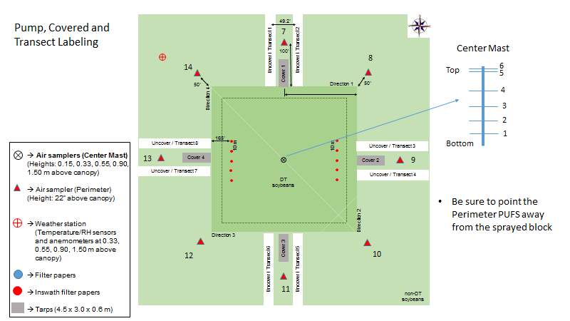

Make sure to position the PUF for the perimeter samplers so the opening of the PVC is facing away from the sprayed block (even if this means that the sampler will be pointing into the wind at the time of application). See Figure 1 for air pump labeling. Pumps and batteries are not waterproof and should be covered in sealed plastic bags to avoid damages. All pumps will be calibrated to deliver a flow rate of 2.9 to 3.1 L min-1. Flow calibration at the beginning and end of each sample period should be recorded for each sampler, including the time each is taken, the number of the calibrator being used and any notes regarding sample collection (i.e. pump not working, PUF possibly contaminated, PUF improperly placed in PVC tube, etc.). The first collection will start approximately 3 hours after the application.

Additionally, to determine the level of background dicamba in the field, 2 pre-application air samples will be collected using air sampling equipment placed near the in-field air monitoring location of the test plot. The samples will be collected 24 h prior to the application time. The sampling time should last approximately 6 hours at a similar flow rate as described before. Samples should be stored separately from all post-application samples.

***4 Sample collection***

All samples should be collected in a manner that reduces the potential for cross contamination. For the center mast sample collection, work from the top down. Additionally, collect all PUF samples first then replace with new PUFS. People collecting samples must change gloves between each sample collection. Specifically, for air samples, additional examples of strategies to avoid contamination include: not touching the open end of the PUF tubes, push/pull PUF into place in the PVC tubing using Tygon tubing connected to pump, changing gloves whenever unintentional contact is made with contaminated equipment, clothing or soybeans. Additionally, use a bamboo skewer provided to push the PUF from the glass tube into the falcon tube as seen in the picture below.

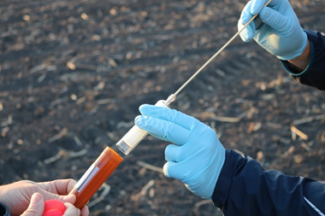

Use one skewer per PUF. The used, empty glass tube is then discarded or saved to be cleaned for later trials. Do not re-use glass PUF holders.

A crew will be designated as clean or contaminated and contaminated crews will not collect any samples outside of the application area and clean crews will not collect any samples inside the collection area.

All samples will be placed in labeled plastic falcon tubes and placed in labeled cardboard boxes in order to isolate samples by distance and direction. Boxes will be double bagged using 2-gallon plastic bags and placed into an appropriate cooler or freezer. All samples must be kept isolated based on type and distance from the application area and stored and shipped in coolers containing dry ice until transfer to storage at -20 C prior to analysis. In-swath samples will be kept isolated from any other filters or PUFs and sent to Bayer Laboratories in St. Louis, MO for analysis. All other samples will be sent to Bayer Laboratories for analysis. The exact sampling scheme will be determined by the Study Director and documented in the field notebook. A standardized field notebook layout, data collection sheets and labels will be provided by the PAT Lab. Please use the shipping addresses below:

**Tank Samples and In-Swath Filters**

Bayer Crop Science – Attn Mathew Juergens

AA5921-A

700 W. Chesterfield Parkway

Chesterfield, MO 63017

**PUFS and Drift Transect Filters**

Bayer Crop Science – Attn Amanda Chen

FF3D

700 W. Chesterfield Parkway

Chesterfield, MO 63017

*4.1 Filter papers*

If possible, a team with two people will work on collecting the filter papers from all transects. The samples will be collected from the furthest to the closest distance from sprayed area. Change gloves after each filter paper collection. Filter papers will be folded in half and then rolled and placed in a plastic tube. The collection will start 30 min after the application concludes.

*4.2 Polyurethane foam (PUF)*

A total of seven to nine samplings will be collected after application depending on the location. The first two samplings will be collected on the application day, which will be divided in two equal intervals. As an example, considering that the applications was performed at 10:00 am, the first and second samplings should be collected by 3 pm and 7:30 pm, respectively. The third, fifth, and seventh samplings should be collected at least 1 h after sunrise, while the fourth, and sixth should be collected at least 1 h before sunset, corresponding to approximately 72-h sampling period. A target hour will be established to represent each interval described above and samples will be collected to the nearest hour.

Air samples will be collected starting from the highest distance above canopy (1.50 m) down to the lowest sample (0.15 m). A group of no more than 4 people will collect the PUFs, splitting the process into specific tasks such as: 1 - measure flow rate of “post sample” PUF and remove from pump; 2 – take the used PUFs, place them appropriately and organize collection tubes and boxes; 3 - attach a new PUF and glass PUF holder for a “pre sample” and recalibrate the air pump; 4 - unwrap new PUFs, record times, flow rates and any other notes for both “pre” and “post” samples.

***5 Biological evaluations***

Spray drift effects on non-DT soybeans will be evaluated by comparing heights and visual rates of plants located under uncovered (transects) and covered (tarp) areas (Figure 1). Plant injuries will be assessed by covering a portion of the soybean crop during the application period to prevent exposure to physical drift. Plants in an area of 50 x 12.5 x 4.9 ft (15.2 x 3.8 x 1.5 m) will be covered a few minutes before the application using a plastic tarp draped over a PVC frame. Landscape pins should be used to secure the tarp edge to the field surface. Use one pin every three feet. One tarp will be constructed in each direction, starting at 3.5 ft from the edge of the sprayed area as shown Figure 1. Care should be taken to ensure the tarps do not interfere with the transects and filter papers.

The tarps will be removed 30-60 min after application. Standardized collection sheets for visual rating and height measurements will be provided.

At 21 days after application (DAA), in the center transects of all directions at the same distances where the filter papers were placed, heights and visual injuries of 3 random plants will be recorded. Similarly, heights and visual injuries will also be taken on 3 random plants which were under tarps at 7, 10, 13, 20, 26, 33, and 49 ft (2, 3, 4, 6, 8, 10, and 15 m) from the sprayed area. Repeat the process of plant height measurements outside of the tarped area using the same distances above.

Height will be measured by holding a plant upright and measuring the distance between the ground and the tip of the most recently emerged apical bud. Where multiple shoots are present, measurements along the main shoot will be taken.

Visual plant response will be assessed on a scale of 0 to 100 with 0 representing no visible plant response and 100 representing complete plant death, according to Frans (1977), Behrens and Lueschen (1979), and Sciumbato et al. (2004). For selected plots and timings, photographs will be taken.

***References***

Behrens, R., Lueschen, W. Dicamba Volatility. *Weed Science*, 27:486-493, 1979. doi:10.1017/S0043174500044453

Sciumbato, A.S., Chandler, J.M, Senseman, S.A., Bovey, R.W., Smith, K.L. Determining exposure to auxin-like herbicides, I: quantifying injury to cotton and soybean. Weed Technology, 18:1125-1134, 2004.

**Table 1.** Collaborators for 2019 Dicamba OTM Large-Scale trials.

|  |  |  |
| --- | --- | --- |
| **Collaborator** | **Affiliation** | **Contact information** |
| Ryan Rector | Bayer CropScience, St. Louis, MO | ryan.rector@bayer.com |
| Matthew Juergens | Bayer Laboratory, St. Louis, MO | matthew.thomas.juergens  @bayer.com |
| Mike Shepard | Bayer Laboratory, St. Louis, MO | Michael.r.shepard.jr@monsanto.com |
| Erik Sall | Bayer CropScience, St. Louis, MO | erik.sall@bayer.com |

**Plot layout for WI**

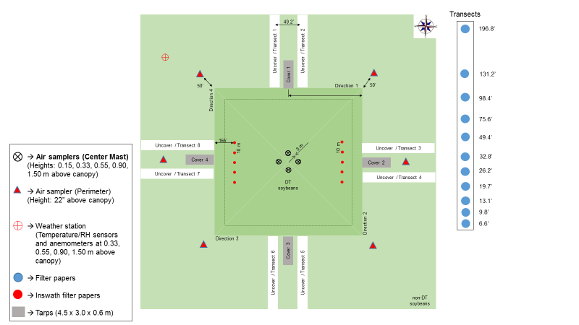

**Figure 1.** Field layout for 2019 Dicamba Large-Scale Trials.

